Stored Procedure Assignment

1. Create the stored procedures using Premiere
2. Submit your SQL, the exec command, and the output to Blackboard

# Stored Procedures to build

1. Create a procedure called showOrders that displays the odernum, orderdate, customername, partnum, part description, quoted price, numordered, and quotedprice * numordered. Order by ordernum. 9 rows returned  
   A screenshot of a computer code

   Description automatically generated  
     
   A screenshot of a computer

   Description automatically generated
2. Modify showOrders to accept a date parameter and only display those orders placed on that date. If you pass in Oct 21 2007 then you will receive 4 rows  
   A screenshot of a computer code

   Description automatically generated  
     
   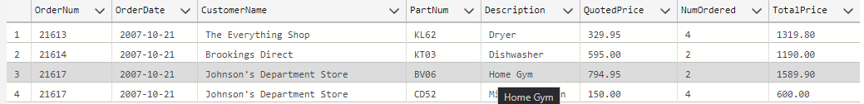
3. Create a stored procedure that accepts a parameter for class. Set a default value for the parameter to ‘AP’. The stored procedure then displays the parts (all fields) for that class. Show the procedure running with both the default value and the passed in value. HW will return 3 records  
   A black and white text

   Description automatically generated  
     
   A screenshot of a table

   Description automatically generated  
   A screenshot of a computer

   Description automatically generated
4. Create a stored procedure that inserts a new record into part. Pass in parameters for all fields that part requires. Set default values for class to AP, Warehouse to 1.
   1. Show **three runs** for the procedure, one that you pass in all 5 values. One that you default class. One that you default warehouse.  
      A screenshot of a computer program

      Description automatically generated  
        
      A screenshot of a computer

      Description automatically generated  
      A screenshot of a computer

      Description automatically generated  
      A screenshot of a computer

      Description automatically generated
5. 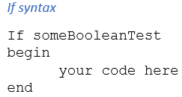Stored procedures can be used to ensure data is correct. Modify the above procedure to test the incoming parameters for correctness.
   1. Ensure price and onhand is larger than 0. Reset the price to 1.99.
   2. Ensure the class is AP, HW, or SG. If not, then force the new part to be AP
   3. If warehouse is not 1, 2, or 3, then force the new part to be in warehouse 1
   4. Provide proof that the procedure works.
   5. Provide proof that each test works, and the value is adjusted. See my output for an example.

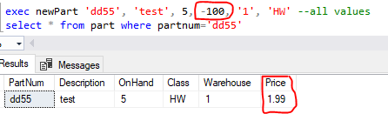

1. Create a stored procedure called newOrderLine. Pass as parameters the ordernumber, partnumber, numberedordered, and discountPercent (decimal(2,2)). Default discountPercent to 0. Default numberordered to 1.  
   The procedure will check the numberordered to ensure it is above 0, and check the discountPercent is between 0 and 0.5. If the discount percentage tests, the stored procedure must stop processing(return) before running the insert. If the numberordered is less than 0, reset it to 1. Once the conditions pass, then the orderline will be written to the database with the quotedprice being the partprice minus the discountPercentage*partprice.
   1. Prove the stored procedure works.
   2. Prove that the checks on numordered and discountPercent

  
  
